|  |  |  |
| --- | --- | --- |
| **LAB221Assignment** | **Type:** | **Short Assignment** |
| **Code:** | **J2.S.P0111** |
| **LOC:** | **64** |
| **Slot(s):** | **2** |

**Title**

Create calculator

**Background Context**

NA

**Program Specifications**

* Use swing library to create a program to simulate calculator with basic functions: add, subtract, divide, multiple, square.

***Function details:***

NA

***Expectation of User interface:***

The screen should be as:

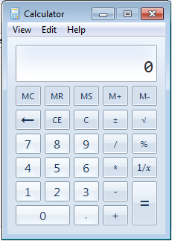

**Guidelines**